Microservices with Spring Boot 3 and Spring Cloud

Creating Microservices for account and loan

Account

package com.cognizant.account.controller;

import org.springframework.web.bind.annotation.GetMapping;

import org.springframework.web.bind.annotation.PathVariable;

import org.springframework.web.bind.annotation.RestController;

import java.util.HashMap;

import java.util.Map;

*@RestController*

public class AccountController {

*@GetMapping*("/accounts/{number}")

public Map<String, Object> getAccount(*@PathVariable* String number) {

Map<String, Object> account = new HashMap<>();

account.put("number", number);

account.put("type", "savings");

account.put("balance", 234343);

return account;

}

}

import org.springframework.boot.SpringApplication;

import org.springframework.boot.autoconfigure.SpringBootApplication;

*@SpringBootApplication*

public class AccountApplication {

public static void main(String[] args) {

SpringApplication.*run*(AccountApplication.class, args);

}

}

Browser port 8080



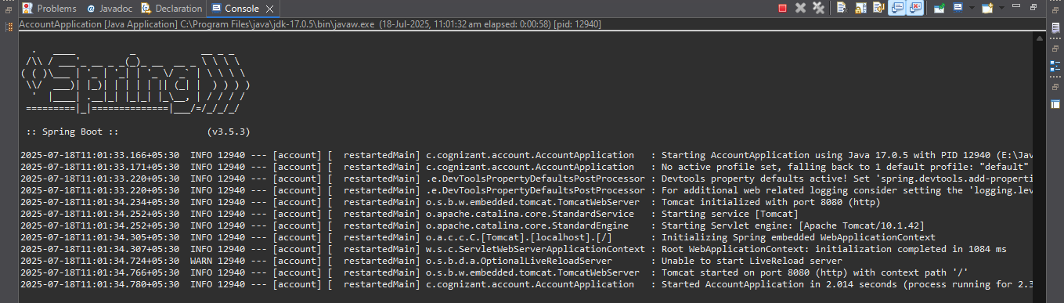

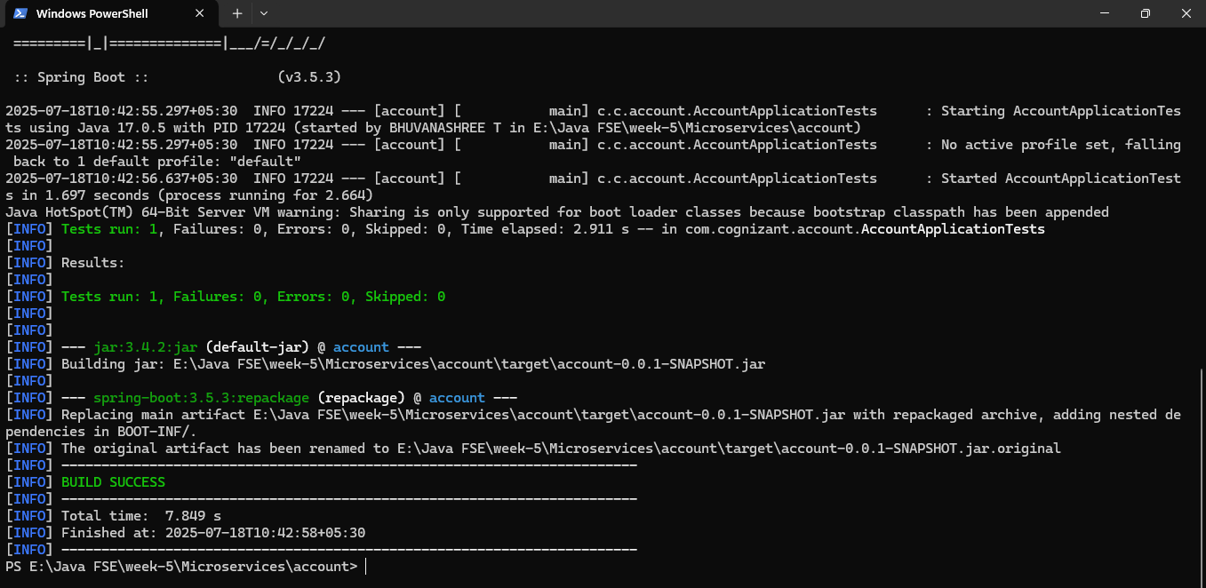

Loan

package com.cognizant.loan.controller;

import org.springframework.web.bind.annotation.GetMapping;

import org.springframework.web.bind.annotation.PathVariable;

import org.springframework.web.bind.annotation.RestController;

import java.util.HashMap;

import java.util.Map;

*@RestController*

public class LoanController {

*@GetMapping*("/loans/{number}")

public Map<String, Object> getLoan(*@PathVariable* String number) {

Map<String, Object> loan = new HashMap<>();

loan.put("number", number);

loan.put("type", "car");

loan.put("loan", 400000);

loan.put("emi", 3258);

loan.put("tenure", 18);

return loan;

}

}

package com.cognizant.loan;

import org.springframework.boot.SpringApplication;

import org.springframework.boot.autoconfigure.SpringBootApplication;

*@SpringBootApplication*

public class LoanApplication {

public static void main(String[] args) {

SpringApplication.*run*(LoanApplication.class, args);

}

}

Browser port 8081

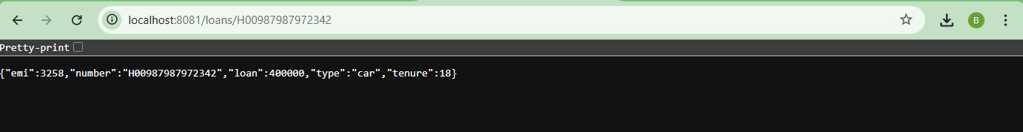

Console

